Required Coding Activity 12.1: Modify a Relational Database in a Container

- A screenshot to show that you opened the Activity 12.1 folder in VS Code.

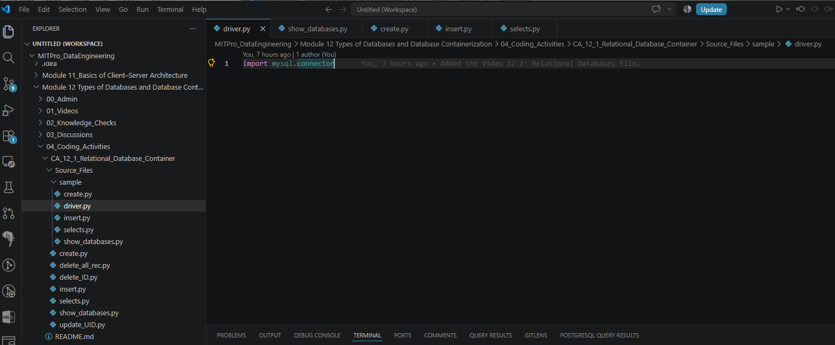

- A screenshot to show that you successfully ran the command to initialize the driver.
Cmd:> docker run -d --name mysql-server -p 3306:3306 -e MYSQL_ROOT_PASSWORD=RootPassword123 -e MYSQL_DATABASE=testdb -e MYSQL_USER=mysqluser -e MYSQL_PASSWORD=UserPassword123 -v mysql_data:/var/lib/mysql mysql:8.4

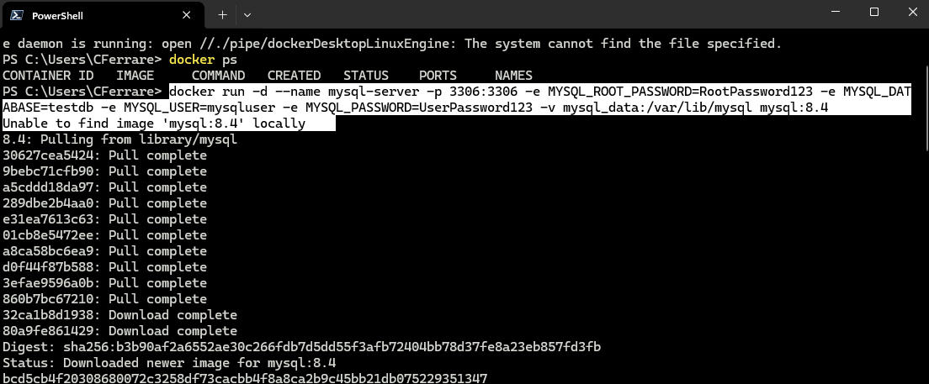

Cmd:> docker ps – is used to list all currently running Docker containers.

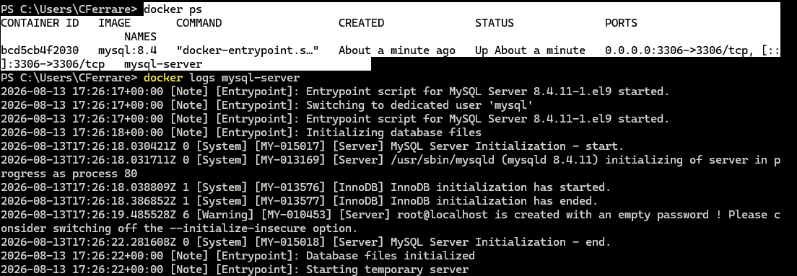

Docker Container in Docker Desktop:
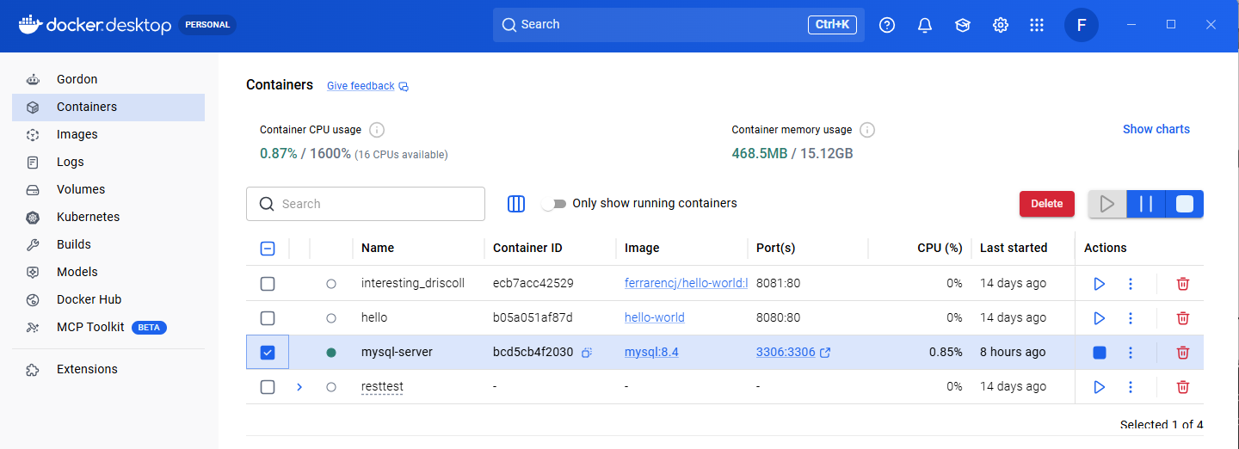
Docker Image was downloaded from previous activity on Module 10:

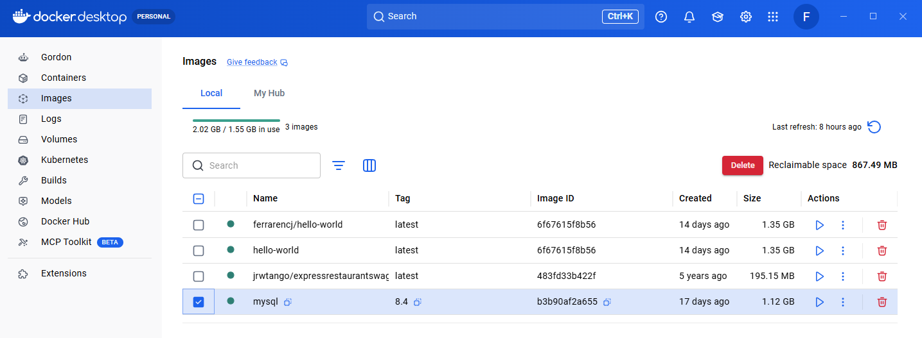

Execute the driver.py python code containing the mysql driver connector.
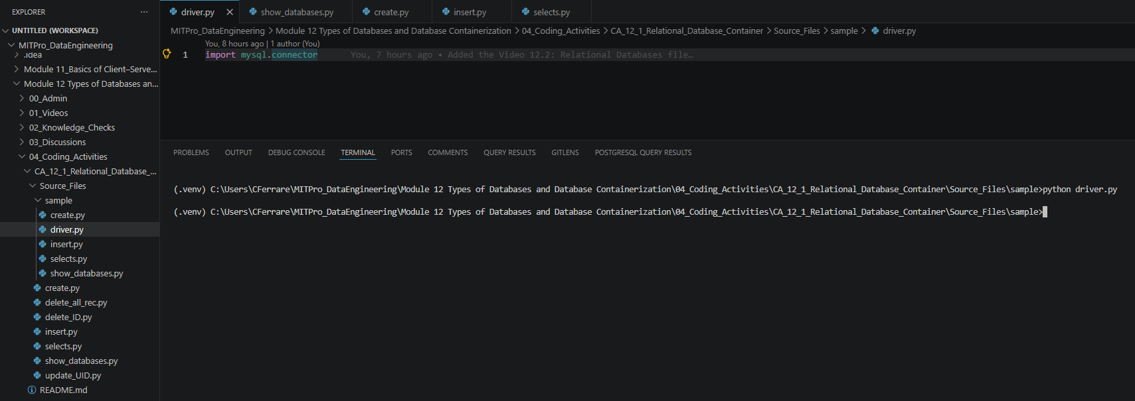

- A screenshot to show the ‘information_schema’, ‘performance_schema’, ‘sys’, and ‘mysql’ databases are in your starter code.

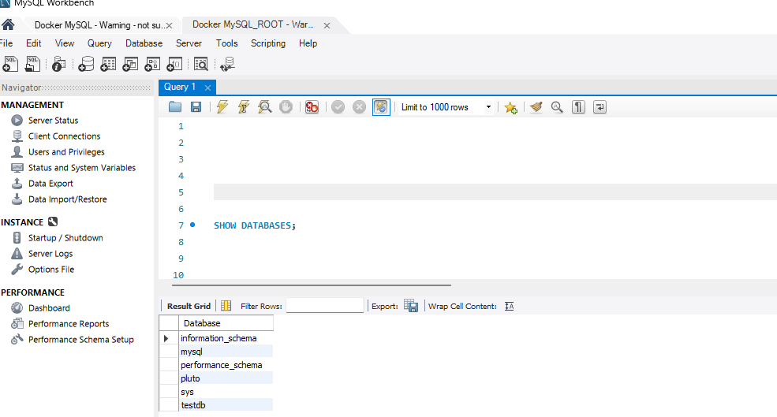

- A screenshot to show that you successfully modified the `create.py` file to create a database called `restaurants` containing two columns.

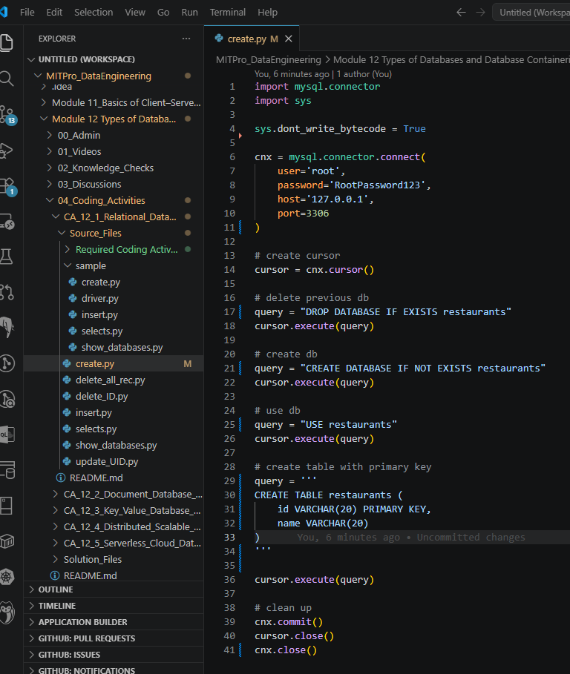

- A screenshot of your Terminal window to show that the ‘restaurants’ database has been created.

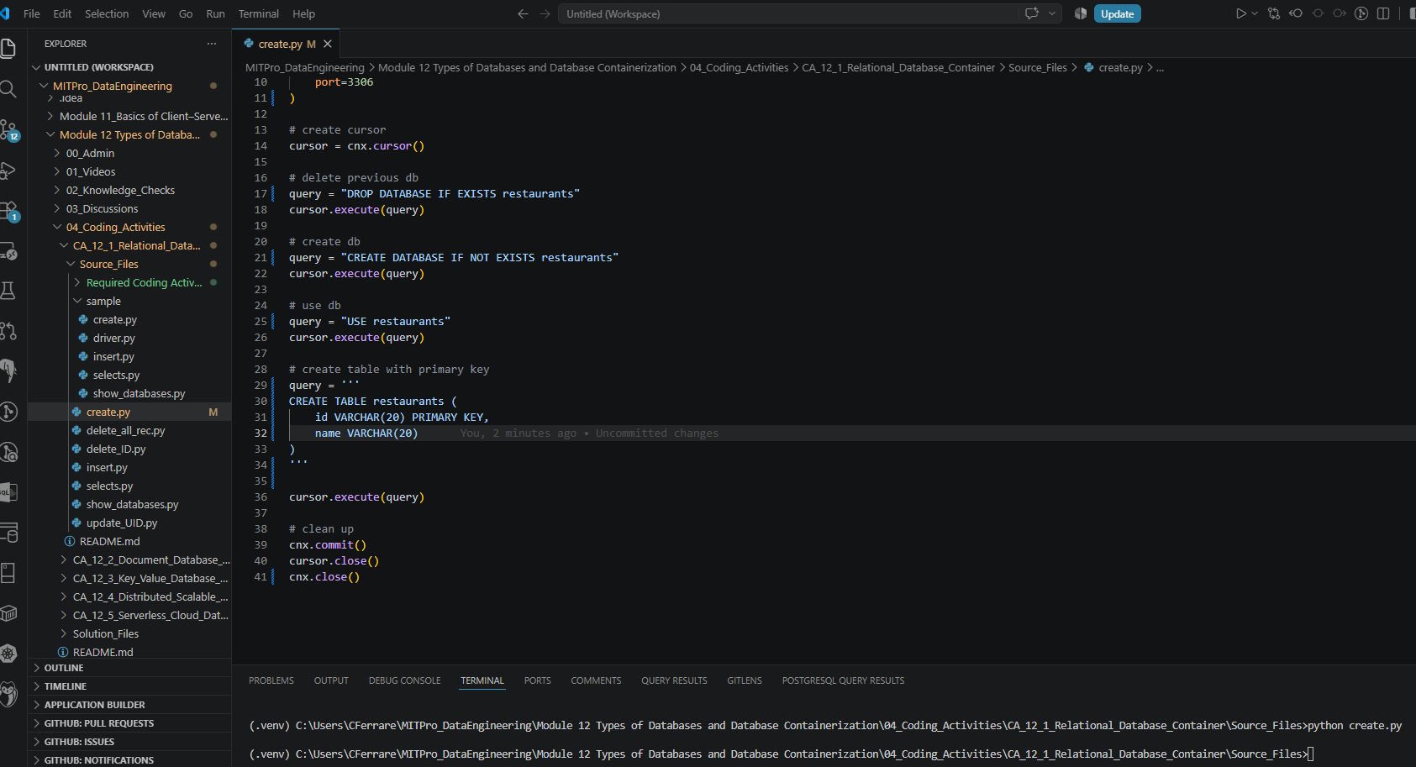

Showing the database and table named restaurants.
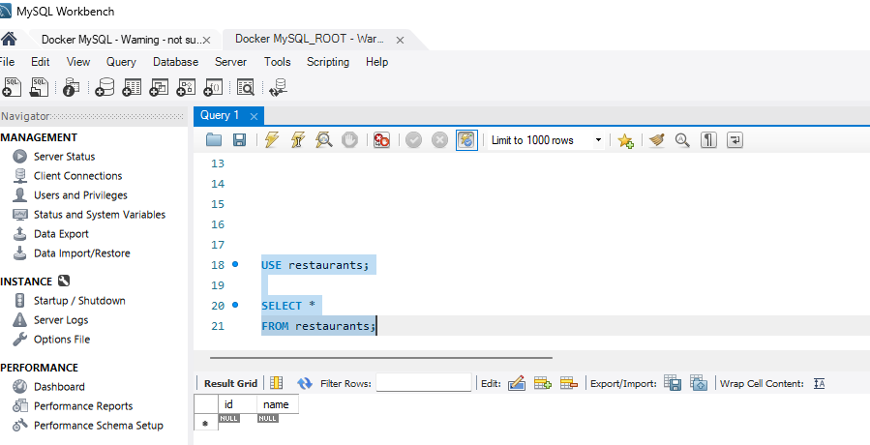

- A screenshot of your modified code in the ‘insert.py’ file to add one restaurant with id equal to 1 and your current time.
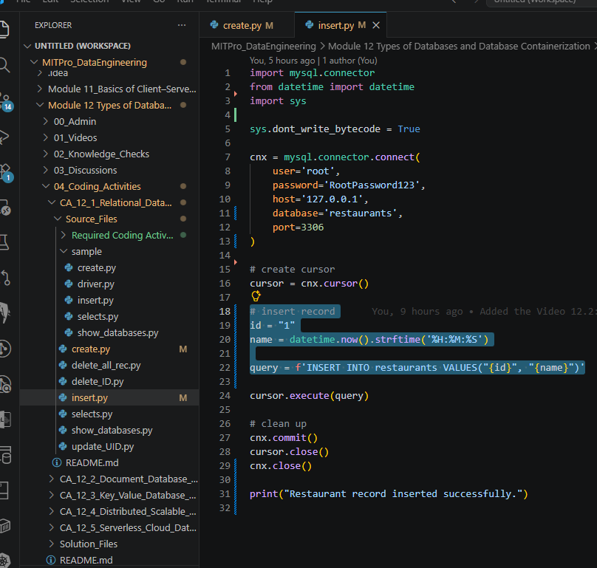

- A screenshot of your Terminal window to show that you ran the correct command to add the entry in the ‘restaurant’ database.

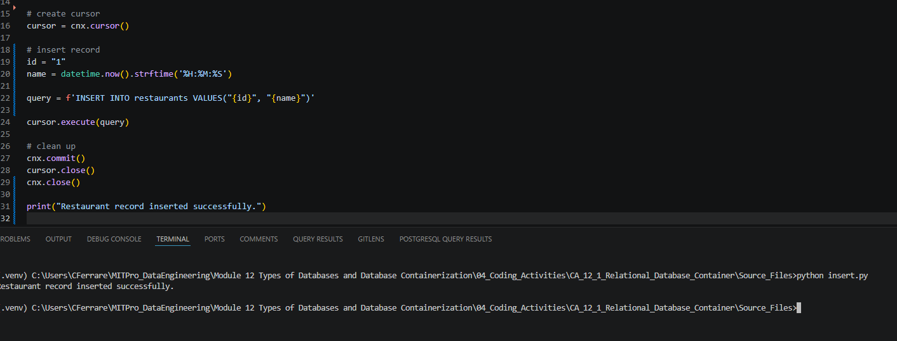

Workbench showing the restaurant database with the inserted record:
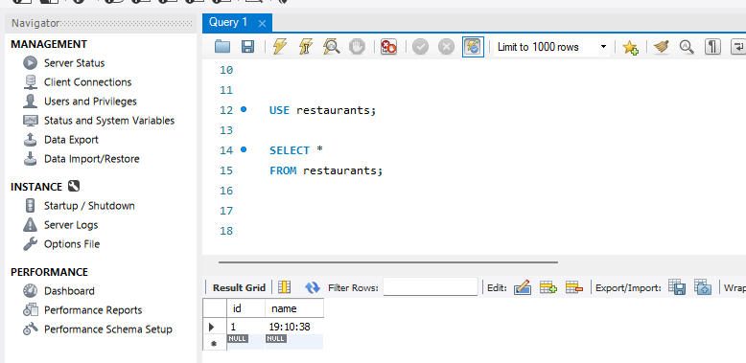

- A screenshot to show that you created a Docker container named ‘my_sql’ using port 3300.

Downloads the official MySQL image from Docker Hub to your machine.
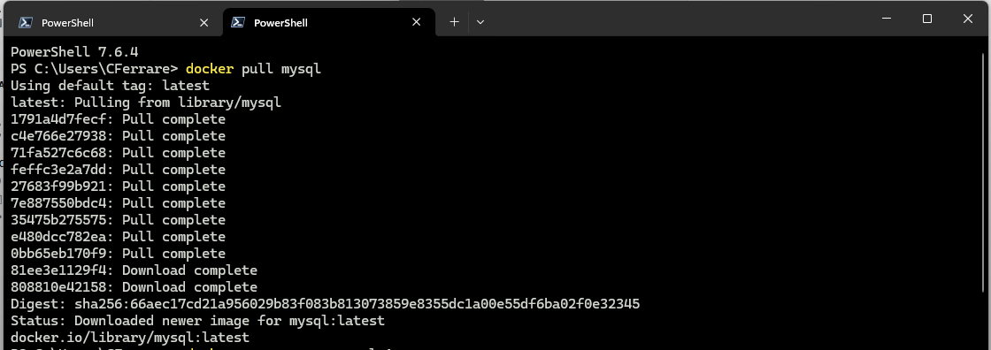

Create a new Docker container from the MySQL image and starts the container immediately.
- Maps port 3300 of my computer to MySQL's internal port 3306.

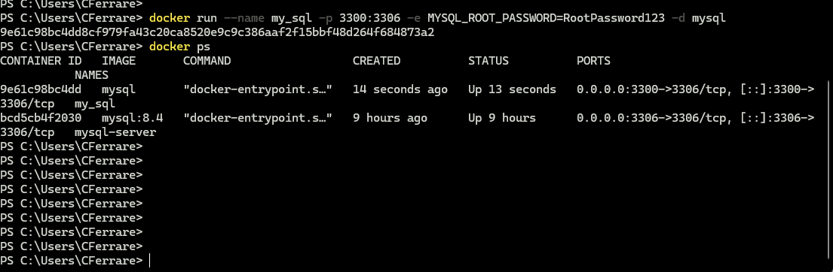

Workbench Connection: 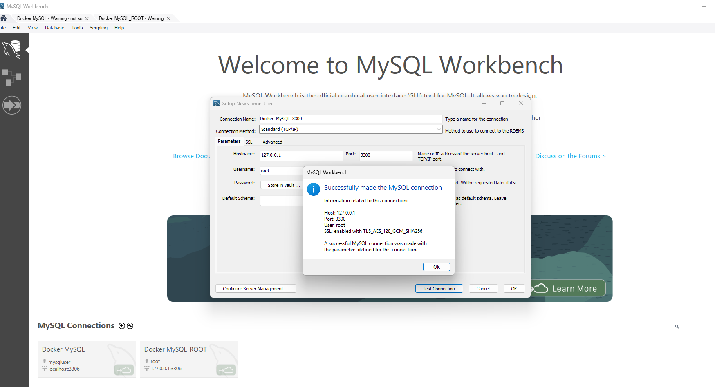

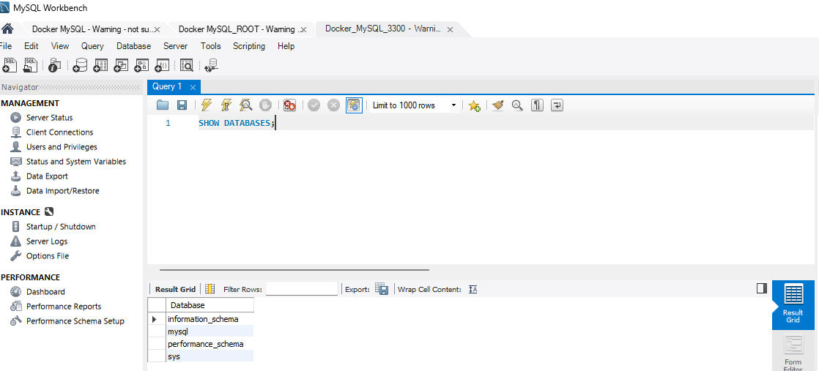

- A screenshot of the ‘show_databases.py’ file while you have the Docker container running to show that everything runs as expected. Note that your screenshot should include both the Docker container running as well as the Terminal window. Feel free to provide two screenshots for this step.
